"This is the peer reviewed version of the following article: Spectroelectrochemical Investigation of the Charge Carrier Kinetics of Gold Decorated Cadmium Chalcogenide Nanorods, which has been published in final form at https://chemistry-europe.onlinelibrary.wiley.com/doi/10.1002/celc.201700798. This article may be used for non-commercial purposes in accordance with Wiley Terms and Conditions for Use of Self-Archived Versions. This article may not be enhanced, enriched or otherwise transformed into a derivative work, without express permission from Wiley or by statutory rights under applicable legislation. Copyright notices must not be removed, obscured or modified. The article must be linked to Wiley’s version of record on Wiley Online Library and any embedding, framing or otherwise making available the article or pages thereof by third parties from platforms, services and websites other than Wiley Online Library must be prohibited."

Spectroelectrochemical Investigation of the Charge Carrier Kinetics of Gold Decorated Cadmium Chalcogenide Nanorods
Jan F. Miethe†, Franziska Lübkemann†, Dr. Jan Poppe, Frank Steinbach, Dr. Dirk Dorfs, Prof. Dr. Nadja C. Bigall*
Institute of Physical Chemistry and Electrochemistry, Leibniz Universität Hannover, Callinstr. 3a, D-30167 Hannover, Germany
†These two authors contributed equally to this work.
*nadja.bigall@pci.uni-hannover.de
Abstract
The interfacial transfer of charge carriers across the semiconductor nanoparticle-electrolyte boundary is an elementary process for applications like photoelectrochemical sensing and photocatalysis. This mechanism is investigated for systems based on complex shaped semiconductor and metal-semiconductor nanoheteroparticles. In the present work the influence of the presence of a CdSe domain within the CdS nanorod as well as the influence of gold domain decoration is investigated spectroelectrochemically. Therefore, the mentioned nanoparticles are linked to transparent indium-tin-oxide (ITO) glass slides via (3-mercaptopropyl)trimethoxysilane (MPTMS). This preparation yields submonolayers of the particles. External photocurrent quantum efficiency spectra are measured in the range from 350 to 650 nm. Intensity modulated photocurrent spectroscopy (IMPS) and electrochemical impedance spectroscopy (EIS) measurements are applied to the samples, in order to reveal and explain the differences of the electrochemical kinetics between the four different particle types (CdS, CdSe/CdS, CdS-Au, and CdSe/CdS-Au nanorods). We demonstrate that the presence of gold domains affects the carrier dynamics of various involved processes. An equivalent circuit model is derived and fitted to the impedance data to explain changes of the kinetics in the system.

Keywords: nanorod, gold domains, submonolayer, charge transfer kinetics, IMPS, impedance

Introduction
In the past decades a manifold of syntheses leading to direct semiconductor nanoparticles was developed.^{[1–3]}The main motivation for this development is to gain exact control of the photoluminescence properties of these structures by controlling size and shape. As a consequence nowadays a manifold of isotropic and anisotropic semiconductor nanocrystals is available, which show strong quantum confinement effects.^{[1,4]} This opens the possibility for various applications such as nanoparticle based photoelectrochemical sensing and photocatalysis.^{[5–10]} The efficiency of both mentioned applications is based on charge transfers between particles and the electrolyte or electrode. The charge transfer process is based on reactions taking place in the millisecond regime.^{[11,12]} and efficiency determining for the mentioned applications.
Cadmium sulfide particles exhibit suitable valence- and conduction band positions for sensing and photocatalysis, which is the reason why the presented work focuses on a common species of these particles in the form of anisotropic CdS nanorods (NRs).^{[1]} The benefit of this particle is the higher specific absorption coefficient in relation to spherical particles of the same material as Angeloni et al. proved by their work.^{[13]} As a reference material CdSe/CdS nanorods are chosen. This system is a pseudo type-II semiconductor heterostructure with a comparable conduction band but different valence band at the CdSe core. The electron is delocalized over the whole particle and the hole localized in the core region.^{[14]} In this system, the CdS nanorod contains a CdSe seed, which has a higher valence band edge, and in which the hole of the exciton is located and preserved. One of the works, which focuses on the electron transfer of CdSe/CdS nanorods to an optical detectable molecule was published by Bridewell et al.^{[15]} This work shows the influence of the rod length on the photocatalytic kinetics of the nanorods by applying femtosecond transient absorption spectroscopy.
Recently metal-semiconductor nanoheteroparticles moved in the center of interest due to their efficient electron hole separation ability and better charge transfer performance.^{[2,16–18]} Recent transient absorption studies suggest that the separation of charge carriers in CdSe/CdS systems by noble metal domains leads to the increase of the exciton lifetime from the nanosecond to the microsecond timescale.^{[19–22]} This is a relevant fact for the field of electrochemistry, since important works with CdS nanoparticles in this scientific area show the development of photocurrents in similar time regimes. We therefore expect that for spectroelectrochemical applications such systems are of high interest since competing relaxation processes, which are typically magnitudes faster (e.g. photoluminescence in the range of 10 ns), are suppressed in these systems, which makes charge carriers better extractable. In case of the CdS-Au system, which is widely used in literature for photocatalysis, Ben-Shahar et al. carried out transient absorption spectroscopy studies to show the influence of surfactants on the hydrogen production rates.^{[23]} A similar reaction is shown with Ni decorated CdS nanorods.⁵
While transient absorption spectroscopy is a powerful method to observe the population of electronic states in the nanoparticles and in the reactants, the charge carrier transfer processes can only be deduced indirectly by this method. In order to observe the charge carrier transfer directly, instead, spectroelectrochemical investigations are necessary, since the photocurrent proportionally correlates with the net transfer rate. Furthermore, also possible back reactions would be observable by this technique.
To gain a deeper understanding of the elementary mechanisms taking place in such systems, we decorated CdS and CdSe/CdS nanorods with gold domains (Figure 1) and compared their spectroelectrochemical properties to those of the pristine nanorods.
For our measurements, all nanoparticles investigated are deposited as submonolayers onto conductive glass substrates. To reveal the kinetics of the investigated systems, the frequency resolved techniques electrochemical impedance spectroscopy (EIS) and intensity modulated photocurrent spectroscopy (IMPS) are applied.^{[11,12,24,25]} A model of the charge transfer process is obtained by equivalent circuits fitting to EIS data. A clear influence of the CdSe seed in case of CdSe/CdS NRs and of the noble metal domains on the mechanisms of interfacial charge transfer is shown.

Results and Discussion
The investigated samples were obtained by linking nanorods via (3-mercaptopropyl)trimethoxysilane (MPTMS) to conductive ITO glasses. Photographs of the investigated sample are shown in the supporting information (Figure SI-1).This procedure is known from preceding photoelectrochemical studies and was also applied to prepare sensors.^{[7,10,26–29]}
Figure 1 TEM images of CdS NRs(A), CdS-Au NRs (B), CdSe/CdS NRs (C) and CdSe/CdS -Au NRs (D).

The preparation of particle submonolayers on ITO slides is in our opinion beneficial for kinetic investigations because it minimizes particle-particle interactions. The optical densities measured for our slides indicate that we indeed formed submonolayers of particles (see Supporting Information Table SI-1 to SI-3). The measured SEM images support these calculations (see Supporting Information Figure SI-2). Under this condition the transport of charge carriers to the electrode across the particles plays, at best, a minor role. There should be only a transport process between two or three particles. Particle-particle charge transport would not be completely distinguishable from interfacial particle-electrolyte charge transfer, since the time scales of these processes are often overlapping.^{[30,31]} In such optically thin samples, every particle absorbs in good approximation the same amount of photons. Non-linear optical effects are excluded by this circumstance. This eliminates the influence of sample layer thickness and enables the determination of the photocurrent quantumefficiency.^{[12,26]}
A main question is how and by which mechanisms the presence of gold domains onto a nanoparticle is changing the electrochemical attributes of the particle. From previous works, it is known, that the Fermi level of the gold domain is under illumination aligning to the conduction band of the CdSe/CdS nanorod.^{[8,33]} The nanorods are an n-type semiconductor.^{[34]} It was shown that the absolute positions of the valence band (VB) and conduction band (CB) of the semiconductor are not changed by growing gold on it.^{[8,32]} The energy levels of the CB and VB are beside the applied bias potential and the redox potential of the electrolyte important elements to explain the main thermodynamic driving force for reactions determining the photocurrent. All of the four mentioned parameters are equal in the investigated systems with and without gold. This means that the electrochemical differences between the pure and the gold decorated nanorods are based on the kinetics and not on the thermodynamics of the system.
We are following two ways to investigate these kinetic changes in the system upon gold growth, namely by electrochemical impedance spectroscopy (EIS) and by IMPS measurements. From EIS, the height of the tunnel barrier from the electrode to the nanoparticles and from the nanoparticles to the electrolyte can be derived, and from IMPS the processes, which are elementary for the development of photocurrent, like the transfer mechanisms of electrons and holes can be distinguished and compared.
It is reasonable and shown by literature that the way of linking particles onto ITO/MPTMS substrates is changing the impedance of the system.^{[29,34]} The organic ligand molecules at the surface of the particle and the distance between the nanoparticle and the ITO, which is defined by the linker molecules, can be interpreted as the tunneling barrier.^{[26,35,36]}
Impedance of the electrode/electrolyte interface. A good approach to compare the height of tunneling barriers in different systems is the fitting of EIS data under the application of equivalent circuit models, which are shown in Figure 2.^{[37]} The height of a tunneling barrier can be depicted as an electrical resistor.^{[38]} In a first step we applied a model to the measured impedance data of particle free MPTMS functionalized ITO (Figure 2 A). This system can be described as a simple version of the common Randles circuit.^{[39]} A Warburg element was not utilized in this circuit, since there were no signs of an electrochemical diffusion layer formation. It is necessary to mention that the application of a constant phase element (CPE) as opposed to a normal capacitor was necessary to describe the impedance of ITO/MPTMS. The values, which were derived from this equivalent circuit like the resistance of the setup and the inner ITO resistance R_{s} the capacitance value of the constant phase element CPE, and the resistance of the ITO/MPTMS-electrolyte charge transfer R_{I/E} are also applied as fixed values in the equivalent circuits of the nanoparticle covered slides.
The impedance of semiconductor and metal-semiconductor nanorod covered ITO/MPTMS was measured under the same experimental conditions as the impedance of the nanoparticle free system. The resistance and capacitance of the mentioned systems was derived by the introduction of an extended equivalent circuit model (Figure 2 B and C), which is a simplified version of the description of titania based Grätzel cells.^{[37]} This model claims a tunneling resistance between ITO/MPTMS and the nanoparticle R_{I/N} and between the nanoparticle and the electrolyte R_{N/E}.^{[36]} It was also necessary to apply a Warburg element W, since higher conductivity was observed, which lead to the formation of a diffusion controlled depletion layer. The additional capacitance of the particles was described by a normal capacitor C. The application of the extended circuit is a simultaneous fitting of two resistors, a capacitor, and a Warburg element, which is in summary the fitting of an additional Randles circuit.
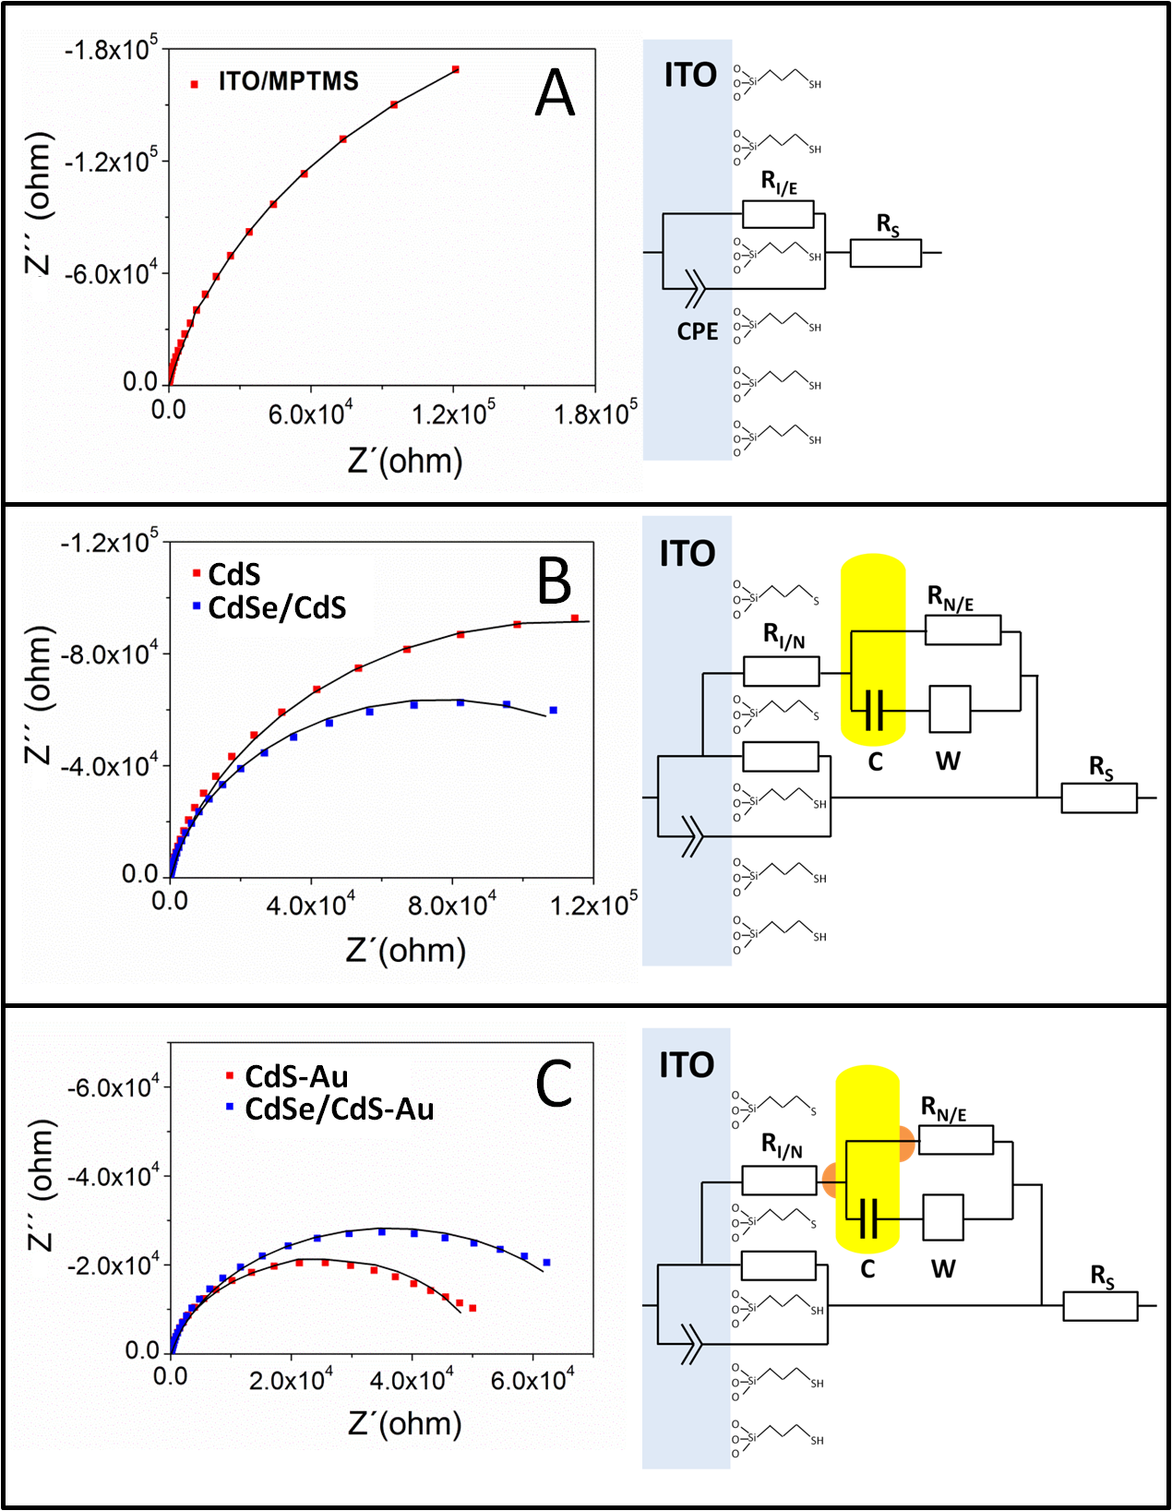
0.1 Hz
1 Hz
10 Hz
0.1 Hz
1 Hz
10 Hz
0.1 Hz
1 Hz
10 Hz
Figure 2 Impedance spectra of MPTMS coated ITO (A), pure CdS and CdSe/CdS nanorods(B) and metal domain decorated CdS and CdSe/CdS nanorods (C). The blue and red squares show the measured impedance values. The lines are derived from fits, which are based on the specific equivalent circuit models right of the graphs. All impedance measurements were done at a bias potential of 300 mV with a potential modulation of 20 mV. The applied frequency range is 1 MHz to 0.1 Hz.

Table 1 Values gained by fitting of equivalent circuits (see Figure 2): ITO resistance (R_{S}), ITO-electrolyte tunneling resistance (R_{I/E}), ITO-nanoparticle tunneling resistance (R_{I/N}), nanoparticle-electrolyte tunneling resistance R(_{N/E}), and constant phase element of the ITO (CPE) and nanoparticles capacitance (C). The values for R_{S,} R_{I/E} and CPE are the same for every system.
Type of System | R_{S}(Ω) | R_{I/E}(Ω) | R_{I/N}(Ω) | R_{N/E}(Ω) | CPE(µF) | C(µF)
ITO/MPTMS | 126 0.1 | 51.5·10³ 0.6 | - | - | 5.6 $±$0.12 | -
CdS | ´´ | ´´ | 7.8·10³$±$ 5.7 | 352.7·10³$±$0.1 | ´´ | 0.3 $±$0.03
CdSe/CdS | ´´ | ´´ | 9.0·10³$±$2.2 | 208.8·10³$±$0.1 | ´´ | 0.5 $±$0.1
CdS-Au | ´´ | ´´ | 89.0 $±$3.7 | 57.5·10³$±$0.9 | ´´ | 1.2 $±$0.6
CdSe/CdS-Au | ´´ | ´´ | 109.3$±$ 6.3 | 84.3·10³$±$0.1 | ´´ | 0.8 $±$0.07

The system ITO/MPTMS has a higher surface resistivity than pure ITO, which is reasonable since the functionalization with MPTMS introduces a non-conductive layer of silica. However, as may be seen from Figure 2, there is a decrease of impedance by the formation of a nanorod submonolayer, which is enhanced by gold domain decoration. These results are in tendency similar to those of other literature sources investigating the influence of e.g. Au nanoparticle deposition on the absolute impedance of ITO/MPTMS electrodes.^{[29,34]} It is necessary to mention, that the lower impedance is not only based on a higher coverage with particles but also on the decrease of the tunneling resistance.^{[36]} This implies that the combined charge transfer over the resistances of R_{I/N} and R_{N/E} should be lower than the transfer across R_{I/E.} The presence of gold domains on the nanorods decreases both barriers further. The measured value of the ITO/MPTMS-nanoparticle charge transfer barrier for gold containing systems is similar to that of a metal-metal contact (Table 1). This phenomenon is explainable with a higher affinity of the mercapto-group of MPTMS to gold (which is less covered with ligands) than to an Cd-rich CdS surface which is already capped with organophosphorus moleculs (TOP/TOPO). This results in a reduced spatial separation of the ITO and the Au domains and a reduced tunnel barrier due to the lack of additional ligands at the site of the Au domains.^{[28]}
The resistance between the nanoparticle and the electrolyte R_{N/E} is a phenomenological description of tunneling, since the electron could probably tunnel directly from the solution into a gold domain and from the same point into the ITO or the electron is tunneling to another gold domain before injection into the ITO as shown in Figure 2 C. Even a hopping across multiple domains would be part of this resistance element. In this way the element R_{N/E} can be understood as a couple of parallel connected resistors.
A second key point for the development of contacts could be the surface mobility of gold atoms, which might partially cause a reorganization of the domains after linking (which however we are unable to exclude).^{[40,41]}
Bias potential dependency of the photocurrent direction. A higher probability for charge carrier transfer enhances the amount of photocurrent, which is obtained in these systems under illumination. Since the photocurrent will depend on the bias potential, which is applied to the ITO, we measured linear sweep voltammograms (LSV) of every sample. The bias potential was sweeped from -650 mV to 300 mV. In this range there is no electrolysis of the electrolyte (0.5 M Na₂SO₃ in water). It should be mentioned that at more negative potentials the nanoparticles and the ITO could be reduced. At more positive potentials the particles would oxidize. As further information cyclic voltammograms, which are measured under the same conditions are contributed in the supporting information (Figure SI-3).
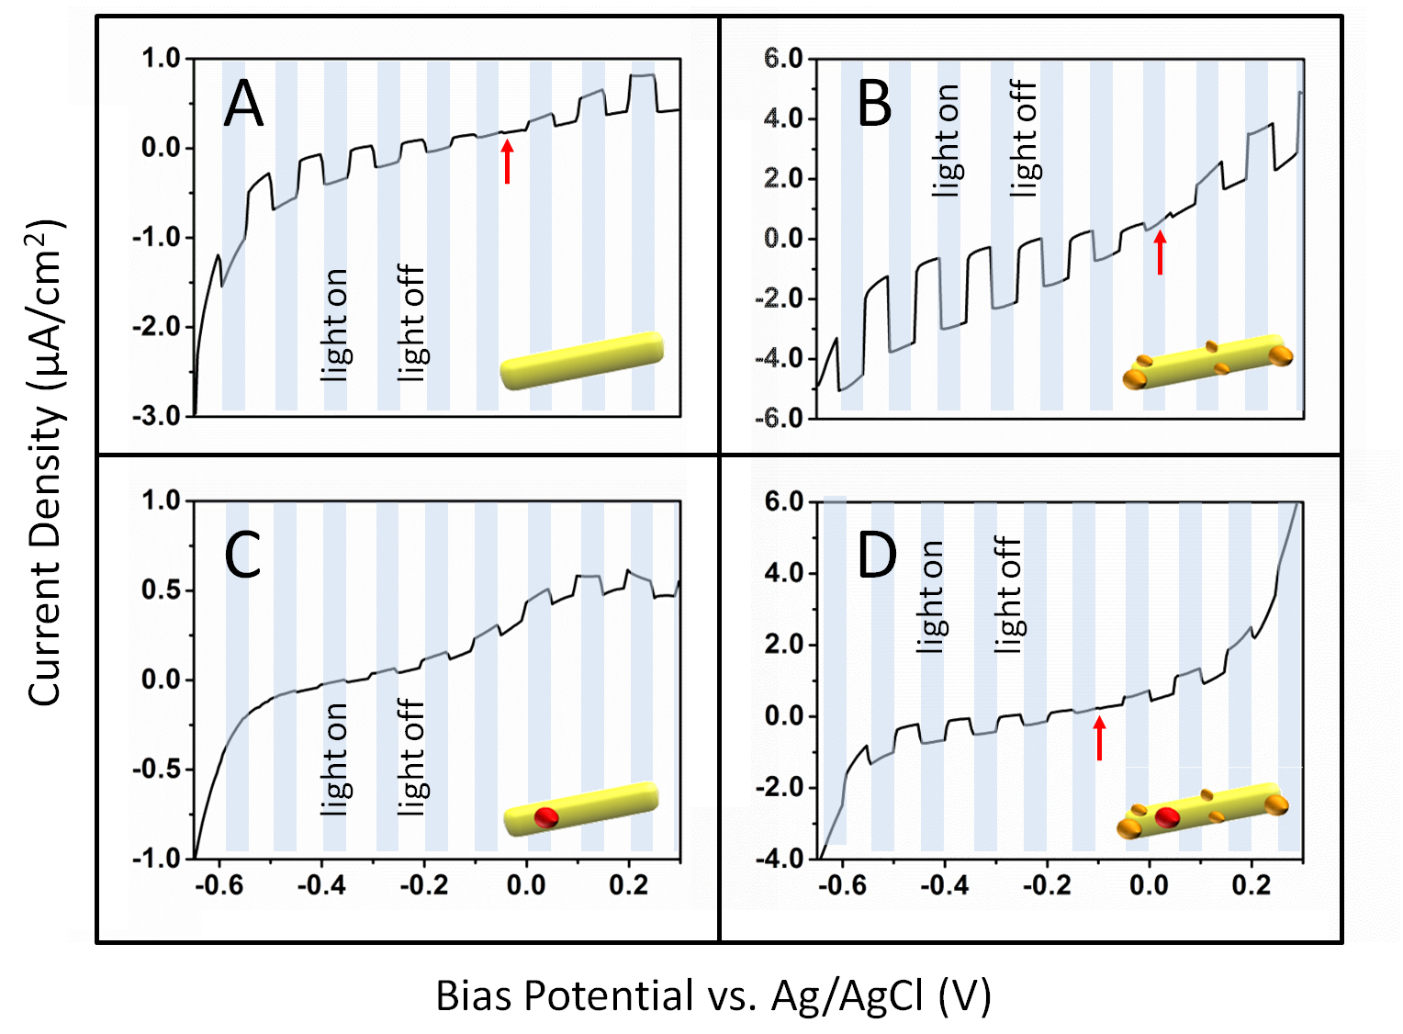
Figure 3. Linear sweep voltammograms of CdS NRs(A), CdS-Au NRs(B), CdSe/CdS NRs (C) and CdSe/CdS-Au NRs (D). The red arrow shows the photoelectrochemical photocurrent switching point from negative to positive photocurrent.

The difference between the currents under illumination with the 468 nm LED (blue background in Figure 3) and the non-illuminated state (white background in Figure 3) is obvious for every investigated system. Except for CdSe/CdS NRs without gold every system shows a photoelectrochemical photocurrent switching point (PEPS). The change of photocurrent direction in case of the different samples is known in literature from various nanoparticle layers on ITO or other substrates.^{[9,42,43]} This result points out that the metal-semiconductor contact in the system is probably not a Schottky barrier-type. In case of a classical Schottky barrier controlled system the photocurrent would have only one direction.^{[44]} There is an extensive discussion in literature about the existence of Schottky barriers, which are based on nanosized depletion region.^{[45,46]} A classical Schottky barrier would be based on the formation of a depletion region, which is larger than the semiconductor particle itself. Nevertheless Schottky barriers in nanoscopic dimensions are also described in case of the CdS rod system.^{[46]} The description of the charge transport as a tunneling dominated process is maybe more suitable. As mentioned, the pristine CdSe/CdS NRs show a positive photocurrent in the investigated area of bias potential. It should be noted that there are variations of the position of the PEPS for varying pH and particle batches (see Supporting Information Figure SI-4). We suggest that the PEPS position is depending on the amount of surface trap states and thus by the ligand coverage of the particles. As already known for comparable systems, the processes which lead to a positive photocurrent are well understood, and are based on the photooxidation of the hole scavenging sulfite ions of the electrolyte.^{[5,26,43,47,48]} All processes which are kinetically necessary for a positive photocurrent are marked as green arrows in Figure 4. In contrast to that the same kind of metal chalcogenide nanorod with gold domains shows at more negative potentials a negative photocurrent (red arrows in Figure 4). It is also necessary to mention, that the current under dark conditions is much higher in case of noble metal decorated particles, since the conductivity of the electrode increased. From the dark current subtracted LSVs, which are shown in the supporting information (Figure SI-5), anoverview of the internal photocurrent efficiencycan be gained. For both pristine nanorod systems (CdS and CdSe/CdS NRs) the photocurrent efficiency increases by a factor of three to four at 150 mV, if metal domaines are deposited onto the nanorods (CdS-Au or CdSe/CdS-Au) (see Supporting Information Figure SI-5, Table SI-4).The optical density of all applied samples is shown in the supporting information (Table SI-5).The energyvalues, which are presented in Figure 4 are derived from the work of Ben-Shahar et al. and adapted to the applied pH-value of 5.6.^{[8]} The adaption of the conduction and valence band position of the metal chalcogenide species is possible, since the effect of the pH onto these energy levels specially in case of CdS nanorods was studied by Simon et al..^{[5]} The shown equilibration of the metal domain Fermi level and the conduction band of the semicondctor by the injection of electrons from the conduction band of the semicondctor is well known in literature.^{[32]}

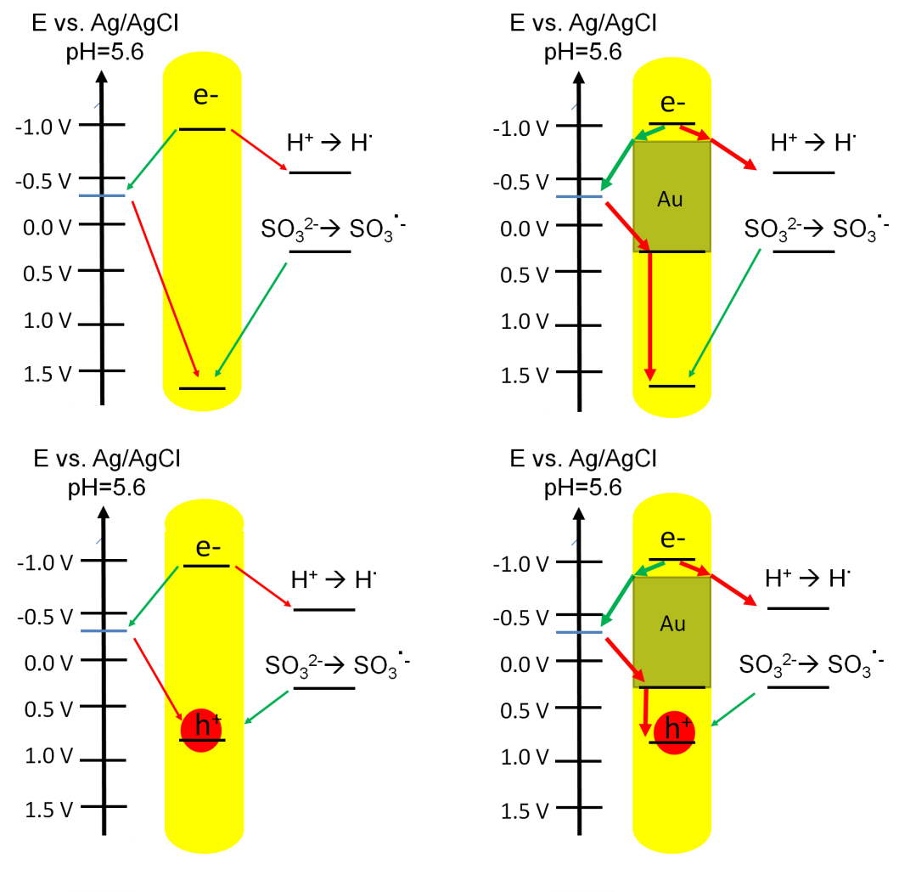
Figure 4 Schemes of the reaction pathways of all four investigated nanoparticle systems are shown. The blue lines demonstrate an exemplary bias potential. Pathways, which are leading to negative photocurrent by proton reduction are marked as red arrows. Reaction pathways, which are leading to positive photocurrent by sulfite oxidation are marked as green arrows. Kinetic pathways which are enhanced due to the gold domains are marked as bolt arrows.
Charge transfer kinetics of the photoelectrochemical reactions. The measured photocurrent is a net value of different reaction rates. In Figure 4 the processes, which are responsible for the development of a negative (cathodic) and positive (anodic) current are marked in red and green, respectively. Kinetic steps like exciton formation, separation, trapping and recombination, which are much faster than microseconds, are not shown in Figure 4 to simplify the scheme. In the supporting information we give a little literature overview about the time scale of these processes (Table SI-6 and SI-7).^{[19–22]} By changing the charge transfer kinetics and with that the rate of the reactions to each other, also the net value of the current gets changed. One possible tool to investigate the charge transfer rates of the two main processes of positive and negative photocurrent development is intensity modulated photocurrent spectroscopy (IMPS). This method is based on a modulation of the photon flux (of an LED) with a sine wave function. The excitation of the system with a photon flux of a given function will lead to a photocurrent, which follows a similar but phase shifted function. The phase difference between the sine wave of the photon flux and the sinusoidal response of the photocurrent at specific frequencies is inversely proportional to the rate constants of the processes taking place in the system.^{[24,49]} If reaction rates are differentiating by one order of magnitude their mechanisms are clearly distinguishable from each other by IMPS.
In Figure 5, the IMPS analysis for all investigated samples is shown. No measurable photocurrent is observed at the high frequency limit of 10 kHz, which means that no system shows any kind of measurable electrochemical process above the noise level faster than 0.1 ms. The maximum measurement frequency of the applied potentiostat is given by the supplier with 1 MHz. The measurement resolution is not limited by applied electronic devices. Even when compensation of the iR-drop is applied, an attenuation of measurement signals by RC effects at the high frequency limit can be present. Attenuation of measurement data at high frequency level by applied wet chemical cell is possible. The RC time for most systems is estimated with about 1 ms. which means that signals at measurement frequencies higher than 1 kHz could be strongly attenuated by the charging process of the system. The general limiting chemical processes in the investigated systems are the transport of charge from the nanoparticle to the electrolyte and the ITO substrate. These processes are based on the charge carrier lifetime in surface states and the tunneling probability of these carriers to the electrolyte and ITO surface.^{[12,20,22]} In case of the CdSe/CdS and CdS NRs, both negative and positive photocurrents are observed. As expected, the mechanisms at bias potentials higher than that of the PEPS are yielding clearly positive current. In case of applied bias potentials more negative than the PEPS, the opposite current direction dominates. Signals of negative photocurrent have in case of Nyquist-plots a negative value on the real axis. For the explanation of the photocurrent kinetics in Figure 5 the standard quadrant numbering system is applied. The measurement points in the second and third quadrant are connected to negative photocurrent and the measurement points in the first and fourth quadrant to positive photocurrent. In all experiments with negative bias potential (with the exception of a -150 mV bias potential in case of the CdSe/CdS-Au system) the negative photocurrent is starting to develop in the second quadrant of the coordinate system. As it can be seen from Figure 5 the negative photocurrent is increasing with decreasing excitation frequencies in the case of negative bias potentials. In the systems CdSe/CdS-Au, CdS and CdS-Au the negative photocurrent stays in the second or third quadrant even at a low frequency of 1 Hz. Only in the CdSe/CdS NR system a turnaround (100 Hz) of the photocurrent into positive direction can be observed. Even at applied potentials of more than 0 mV in all systems a small negative photocurrent is visible, which switches into a positive photocurrent by passing from the third into the fourth quadrant at frequencies of 160 to 630 Hz (Figure 5).
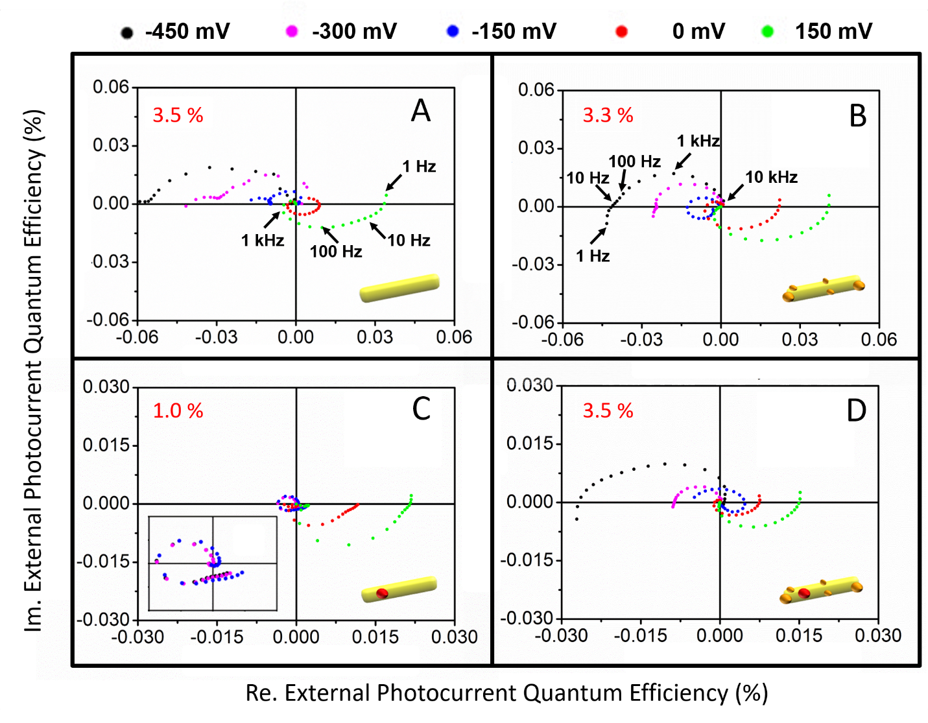
Figure 5 Intensity modulated photocurrent spectra of CdS NRs (A), CdS-Au NRs (B), CdSe/CdS NRs (C), and CdSe/CdS-Au NRs (D). The spectra are measured under 468 nm LED illumination with frequencies from 10 kHz to 1 Hz at bias potentials of -450 mV (black), -300 mV (magenta), -150 mV (blue), 0 mV (red), and 150 mV (green). The proportion of absorbed photons of the samples at 468 nm is given as a number in red front in the upper left corner. For a better experimental overview, the applied LED frequencies are outlined for the CdS system at a bias potential of 150 mV (A) and a CdS-Au system at a bias potential of -450 mV (B). This should provide the possibility to give an insight at which frequency range large changes of the photocurrent occur.

The IMPS experiments contain the mechanistic answer to the question why the LSV of CdSe/CdS NRs shows no switching point. At potentials lower than 0 mV where other samples show a negative signal, the CdSe/CdS NRs develop at the beginning also a cathodic photocurrent but at frequencies higher than 100 Hz the direction of the photocurrent changes into anodic. At frequencies lower than 16 Hz the net photocurrent becomes positive (Figure 5). This phenomenon is reproducible with different CdSe/CdS samples. Instead, without a CdSe core, which introduces a relatively high valence band potential into the system and causes an immobilization of the hole, this phenomenon does not occur, as it was seen in experiments with pure CdS NRs. Furthermore, the growth of gold onto CdSe/CdS NRs also leads to the appearance of a PEPS.
One of the main questions is, which mechanism is responsible for the different behavior in case of the CdSe/CdS system and causes the negative photocurrent to disappear at illumination frequencies higher than 100 Hz. Since the external photocurrent efficiencies are quite low, and since systems with even higher efficiencies than pure CdSe/CdS NRs do not show the disappearance of the negative photocurrent, it is reasonable to assume that the formation of electrolyte depletion layers is not responsible for any mechanistic phenomenology observed here.
We suggest the following mechanism: After the exciton formation, the hole gets preserved in the CdSe core of the rod. Our studies show clearly a photoelectrochemical activity of the material even in the case when only the CdSe core is illuminated (Figure 6 C). This proves that the tunneling of electrons into the rod is still possible when a core exists. However, the existence of a CdSe core decreases the delocalization of the hole drastically. This could lead to a decrease of the transfer rate of electrons from the ITO electrode to the holes in the CdSe cores. If the hole does not recombine with electrons injected from the ITO electrode, the hole can also recombine with electrons injected from the hole scavenger sulfite of the electrolyte (Figure 4).^{[47]} This phenomenon is also known as back electron transfer.^{[12]} The sulfite based hole scavenging process will yield a positive photocurrent. We presume that this back electron transfer is dominating in case of CdSe/CdS nanorods since the negatively charged sulfite is likely to be adsorbed near the positively charged CdSe cores, especially when the electron of the exciton has been transferred to the solution and the hole remains in the particle leading to a more positive charge.^{[50,51]} Hence, at excitation frequencies lower than 100 Hz the preserved holes are recombining under the consumption of the hole scavenger.^{[12]}
The gold growth onto CdSe/CdS NRs has several effects, which are changing the kinetics drastically. A manifold of literature sources show that the Fermi level of gold aligns to that of the semiconductor nanoparticle. By this phenomenon a broad distribution of new energy states is created which can be occupied (Figure 4).^{[8,32]} As the TEM images (Figure 1) prove the distribution of gold on various sites of the semiconductor, it is reasonable to assume that these states are geometrically distributed all over the rod.
It is shown by our impedance measurements that the charge transfer barriers between ITO and gold covered nanoparticles and between the particle and the electrolyte are much lower than those of the pure semiconductor particles. A decrease of the charge transfer barriers will increase the possibility to inject electrons from the ITO electrode into the valence band of the nanoparticle. The charge injected into the gold states is relatively mobile within the nanorod across the multiple Au domains, and should be able to quench the trapped hole inside the CdSe core much faster than in case of the pure CdSe/CdS NRs (in which case the charge transfer must occur directly to the CdSe).
Regarding the excited electron, two different processes can take place. In case of the pure semiconductor nanorods (both CdS and CdSe/CdS), the electron is likely to be transferred directly to the protons in solution resulting in hydrogen formation. This process occurs in the time range of 0.2 to 1 ms (Figure 5). However, from photoluminescence decay measurements it is shown that the direct recombination of excited electrons and holes is with 23 ns (measured for the CdSe/CdS nanorods) much faster and therefore concurring with the photocurrent formation. In case of the gold domains grown on the nanorods, however, the electron can be transferred to the gold domains first (2.2 to 800 ps),^{[20,21]} which is in this case much faster than the direct recombination. Electrons on the gold domain have a much longer lifetime (more than 10 µs)^{[19,21]} and can from this state either transfer back to the hole or contribute to the photocurrent by reducing protons from solution. A complete overview of the fast intrinsic particle kinetics is shown in the supporting info (Figure SI-6).
In summary, a photocurrent amplification by noble metal domain growth of the factor 3 to 4 at a bias potential of 150 mV can be observed in case of the CdS and CdSe/CdS nanorods (see Supporting Information Figure SI-5 and Table SI-4). At a bias potential of -600 mV photocurrent in case of CdSe/CdS can only be observed for the gold domain decorated system.
Wavelength dependency of the photocurrent. If the semiconductor shows a classical pseudo type-II character, and if all exciton formation, recombination and trapping processes are much faster than the recombination processes via trap state or via the charge transfer processes (see Supporting Information Table SI-6 and SI-7), there should be no wavelength dependence of the internal photocurrent efficiency (the internal photocurrent efficiency is defined as the external photocurrent efficiency divided by the absorption spectrum). A comparison of the wavelength dependent external photocurrent efficiency to the absorption spectra of the particles in solution shows the direct proportionality of both values (Figure 6). This indicates no drastic change of the internal quantum efficiency, except for the absorption related to gold and for slight measurement artifacts. External photoefficiency (EPE) spectra of CdS, CdSe/CdS, CdS-Au and CdSe/CdS-Au NRs at an applied bias potential of 150 mV show nearly the exact slope of the related absorption spectra (Figure 6). This result is not surprising since the investigated submonolayers should show an optically linear behavior, which is based on the circumstance that every particle is illuminated at every wavelength by the same amount of photons. In case of Au domains present, however, the EPE spectra differ from their absorption spectra slightly, since the absorption caused by the Au domains does not contribute to the photocurrent. For later discussions it is necessary to mention, that also at wavelengths near 600 nm, were only the CdSe core can absorb, a photocurrent exists (Figure 6 C). A photoelectrochemical activity of the CdSe core is proven by this phenomenon.
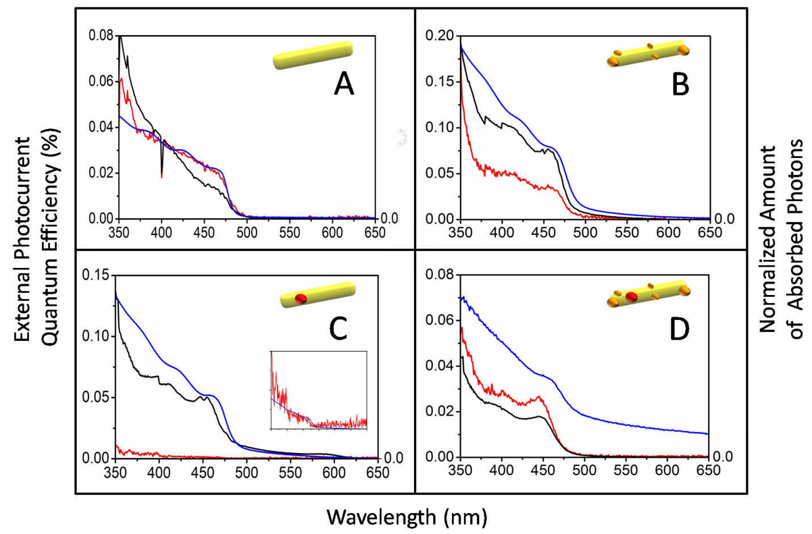
Figure 6 Photocurrent spectra at 150 mV bias potential (black), -600 mV bias potential (red) and absorption spectra of the appertaining particles in solution (blue) of CdS NRs (A),CdS-Au NRs (B),CdSe/CdS NRs (C), CdSe/CdS-Au NRs (D). The spectra of CdSe/CdS NRs at a bias potetntial of -600 mV is shown as an inset in part C.
At a bias potential of -600 mV the CdS, CdS-Au and CdSe/CdS-Au systems show remarkable photocurrent. In expectation, the CdSe/CdS system has a low photocurrent (Figure 6 C). This is in good agreement with the LSV of the systems, which does not show any kind of photocurrent at this potential (Figure 3). We attributed this low photocurrent to the short distance to the PEPS at this potential. A kinetic explanation for this phenomenon is given in the section “Charge transfer kinetics of the photoelectrochemical reactions”.
In case of particles with gold domains, the EPE spectra look quite similar at both probed bias potentials with the only difference that there is no distinct electrochemical activity of the CdSe core recognizable. This is probably caused by a competitive absorption of photons by the gold domains at this wavelength regime.
As the gold decorated particles have a strong negative photocurrent at -600 mV they show EPE spectra, which are in shape quite similar to that at 150 mV. The absorption spectra of gold decorated CdSe/CdS NRs was measured in an integration sphere to eliminate the effect of scattering at higher wavelengths. Comparable absorption spectra for metal decorated metalchalcogenide nanoparticles have been found in literature.^{[2,16,52]} ITO itself absorbs photons in the UV/Vis regime (see Supporting Information Figure SI-7). The high external photocurrent efficiency at wavelengths lower than 400 nm is caused by the ITO, which itself is a highly doped semiconductor and can produce photocurrents when exited at these wavelengths.
The EPE spectra of submonolayers of particles are in summary directly proportional to the absorption coefficient of the semiconductor, and there is no wavelength dependency of the intrinsic photocurrent efficiency in the area of the applied bias potential. The evaluated EPE spectra are a good proof that we obtain samples, which show an optical linearity in case of their electrochemical behavior. We suggest, that the spectral mismatch between the normalized photoconductivity spectra of the NRs and the absorption of them is based on multilayer sample preparation, which yields non optically linear samples.^{[53]} An application of the optical density as unit in the absorption spectra is insufficient, since the optical density is by definition a logarithmic value and cannot be compared to linear ones like the normalized photocurrent or photocurrent efficiency.
Since the ITO slides them self exhibit a photoelectrochemical activity at wavelengths smaller than 400 nm, an excitation wavelength should be chosen at longer wavelengths than 400 nm in order to carry out further experiments like kinetic studies.
The different electrochemical behaviors of the investigated nanoparticles in the LSVs cannot be explained by thermodynamic driving forces, which are based on the difference of the energy levels between conduction band, valence band, redox-potential of the electrolyte and bias potential applied to the ITO (Figure 4). We use in all our experiments an electrolyte with the same formulation and exact controlled bias potential, which means that there should not be any difference in these energy levels. Since the growth of gold onto a semiconductor nanoparticle only causes an alignment of the Fermi levels of both materials to each other, the absolute band positions of the material are not changed. However, impedance measurements prove a change of electronic properties (Figure 2), which therefore have to be interpreted as modifications of the kinetics of the system.
Conclusion
It was possible to resolve elementary variations in the photoelectrochemical kinetics between a pure anisotropic CdS nanocrystal with a free moving exciton and a CdSe/CdS pseudo type-II heterostructure with a strongly localized hole. We obtained an explanation for this difference by assuming that the immobilized hole cannot as easily recombine with the electron injected from the ITO-electrode as in the case of CdS nanorods. Growth of noble metal domains onto the surface of the NRs changes this attribute completely. Our impedance measurements support the explanation that the gold decorated NRs are stronger linked to the ITO substrate, which enhances the electron transfer from the ITO to the nanoparticles for the recombination with the hole.
For pure CdS and CdSe/CdS NRs we see a recognizable amplification of the photocurrent, respectively the intrinsic photocurrent efficiency, by growing gold on them.
Our results indicate that the formation of a semiconductor-metal hybrid structure could be beneficial for applications like photoelectrochemical sensing or photocatalytic reduction. In the case of the investigated CdSe/CdS NRs, the hybrid structure with gold domains seems even to be necessary to measure negative photocurrent under the chosen conditions, since the switching point to a negative photocurrent develops at a bias potential of -0,1 V vs. Ag/AgCl (Figure 3). This is in good agreement with the results of Yue et al. and Zhao et al., which show that the growth of Cd domains or noble metal domains onto CdSe nanoparticles makes proton reduction possible.^{[9,43]} The observation shows that, especially in case of more complicated semiconductor structures, the ITO-nanoparticle interconnection plays a key role for the electrochemical behavior. This opens the question which surface modifications are in quality and quantity suitable to amplify the performance of the systems, which will be the focus in future works.

Methods
Experimentals
Reagents. Cadmium oxide (CdO, 99.998 %) and selenium (Se, 99.999 %) were purchased from Alfa Aesar. Bis(trimethylsilyl)sulfide (97 %), gold(III)chloride (AuCl₃, 99 %), tri-n-octylphosphine oxide (TOPO, 99 %), tri-n-octylphosphine (TOP, 97 %) were purchased from ABCR. Hexylphosphonic acid (HPA, ≥ 99 %), octadecylphosphonic acid (ODPA, ≥ 99 %) were purchased from PCI synthesis. Ammonium hydroxide solution (NH₄OH, 28 – 30 %), acetone (>99 %), didodecyldimethylammonium bromide (98 %), dodecylamine (DDA, 98 %), hydrogen peroxide H₂O₂ (35 %), (3-mercaptopropyl)trimethoxysilane (MPTMS, 95 %), octadecene ODE (90 %), sodium sulfite (≥ 98%), sulfonic acid (95 %), sulfur S (99.98 %), tributylphosphine (TBP, 97 %) were purchased from Sigma Aldrich. Methanol (≥ 99.5 %) and toluene (99.9 %) were purchased from Carl Roth. Substrate: Indium tin oxide glass 1.1 mm coated unpolished soda lime float glass, VisionTek, 12 ohms/sq.

Synthesis of CdSe Seeds. The synthesis of CdSe seeds was performed following the method of Carbone et al. with certain modifications.^{[1]} Briefly a synthesis mixture for the growth of CdSe seeds was prepared by placing 0.06 g CdO, 3 g TOPO and 0.17 g ODPA in a 25 mL three neck flask. The mixture was heated up to 150 °C under vacuum and degassed for 1 h. Subsequently, the temperature was increased to 300 °C under argon, and 1.8 mL TOP was injected. The mixture was heated up to 380 °C to obtain a clear solution. Then, 1.8 mL TOP:Se (0.4 mmol) solution was quickly injected into the solution. The temperature recovered before quenching with 6 mL ODE. Red fluorescent CdSe seeds were obtained. After cooling the reaction mixture, 5 mL toluene were added at 70 °C and the CdSe seeds were precipitated by the addition of 5 mL methanol and subsequent centrifugation. The solution was purified by repeating the toluene/methanol addition and centrifugation twice and eventually stored in toluene.

Synthesis of CdS Seeds. The synthesis of CdS seeds was also conducted following the procedure of Carbone et al. with certain modifications.^{[1]} For the synthesis mixture 0.1 g CdO, 3.3 g TOPO, 0.6 g ODPA were mixed in a 25 mL three-neck flask, heated up to 150 °C and degassed for 1 h under vacuum. Subsequently, the solution was heated up to 320 °C under argon atmosphere followed by the injection of 9.12 mL TBP containing 0.6 mL (TMS)₂S. The reaction mixture was kept at 250 °C for 7 min and cooled down to room temperature by removing the heating mantle. At 70 °C 5 mL toluene were added to the mixture and the CdS seeds were precipitated by the addition of methanol and centrifuged. The CdS seeds were purified twice and stored in toluene.

Growth of CdS shell. The CdS shell growth is adapted from Carbone et al. and is the same for both seed types.^{[1]} Therefore, 0.06 g CdO, 3 g TOPO, 0.16 g OPDA and 0.08 g HPA were placed in a 25 mL three neck flask, heated up to 150 °C and degassed for 1 h. The temperature was increased to 300 °C under argon atmosphere, and 1.8 mL TOP was injected followed by increasing the temperature to 380 °C. At that temperature 1.8 mL TOP:S (2.21 mmol) containing400 µM of the CdSe or CdS seeds were quickly injected and the reaction was further heated for 8 min before the reaction cooled down to room temperature by removing the heating mantle. The mixture was diluted with toluene and precipitated by adding methanol and subsequent centrifugation. The purification step was repeated twice and the NRs were stored in toluene.

Gold growth on CdSe/CdS and CdS NRs. Gold domains on NRs were grown according to a modified method of Menagen et al..^{[17]} For the gold growth solution 275 mg DDA, 172 mg DDAB, 27 mg AuCl₃ and 41 mL toluene were mixed and sonicated for 30 min followed by heating up to 40 °C for 30 min under argon atmosphere. In another 100 mL three-neck flask, the nanorods were dissolved in 68 mL toluene. The optical density of the resulting solution was 1.4 at the first electronic transition maximum of CdS. The system was heated up to 40 °C for 30 min under argon atmosphere. Subsequently, the gold precursor solution was injected with a glass syringe to the NR solution, and the synthesis mixture was heated for 30 min before quenching with acetone and cooling down to room temperature. The nanoparticles were centrifuged, purified twice with a mixture of toluene/acetone, and stored in toluene.
Preparation of ITO Slides

The ITO glass slides were cut into pieces of approximately 15 x 25 mm and cleaned for 24 h with a mixture of 1:1:5 volume parts of hydrogen peroxide (25%) : ammonium hydroxide (25%) : deionized water. The cleansing process was carried out in a beaker. During the first two hours the process was kept at 60 °C, followed by keeping the system at room temperature. During the cleansing process five slides were placed in a self-made poly(tetrafluoroethylene) holder, which kept the slides upright and guaranteed a maximal contact between the slides and the stirred cleaning mixture. Afterwards the slides were at least rinsed with deionized water and toluene.

After drying the slides were immersed in a toluene based solution of 1 vol% MPTMS for at least one day in the same setup as during the cleansing procedure. In the first two hours of reaction the system was kept again at 60 °C. Evaporated toluene was always refilled. The functionalization was ended by taking the slides out of the reaction solution and dipping them into a bath of 50 mL toluene to get rid of residual unreacted MPTMS.
The investigated nanoparticles were brought onto the ITO slides by storing them in a toluene solution of the specific particles for at least 24 h. By using total volumes of 10 mL of coating solution in capped 22 mL vials and placing the vials on the side it was paid attention to the fact that no side of the slide was touching the glass. The total concentrations of cadmium in the coating solution were 15.2 mmol/L. After coating with the nanoparticles, the ITO-free side of the glass plates was wiped with a toluene soaked lintless tissue.
UV/Vis and Photoluminescence
A UV/Vis spectrophotometer of the type Agilent CARY 5000, which was equipped with an integration sphere, was applied to measure scattering free UV/Vis absorption spectra (Diffuse Reflectance Accessory with center mount option) of nanoparticle covered slides. The absorption spectra of the colloidal nanorod solutions can be seen in Figure 6. Examples for UV/Vis absorption spectra of the nanoparticles on ITO/MPTMS slides can be seen in supporting information (Figure SI-7 and SI-8).
Since the sample of the CdSe/CdS nanorods was the only one with recognizable photoluminescence (Figure SI-1), emission, excitation and fluorescence lifetime spectra of these NRs in solution and on ITO (Figure SI-9, SI-10 and SI-11) were measured with a spectrometer of the type Fluromax-4, which was purchased from Horiba. Fluorescence lifetime measurements were carried out the Fluromax-4 was combined with the Fluorohub time-correlated single photon counting (TCSPC) unit.
TEM and SEM Measurements
For TEM investigations the instrument FEI Tecnai G2 F20 TMP (C_{S} = 2 mm, C_{C} = 2 mm), equipped with a 200 kV field emission gun was used. Micrographs were taken in bright field mode. For grid preparation, 10 µL of the purified sample was dropcasted on a 300 mesh carbon coated copper grid, purchased from Quantifoil.
The film texture was investigated by scanning electron microscopy (SEM) using a JEOL JSM-6700F equipped with cold field emission gun electron gun. The samples were fixed with conductive silver paint on the holder and sputtered with a carbon layer.
Electrochemical Methods

A ModuLab XM ECS Potentiostat from Solatron, a 7270 general purpose DSP lock-in amplifier from Signal recovery, Hameg HMF 2525 frequency generator from Rohde und Schwarz, a chopper of the typeC-995 manufactured by Terahertz Technologies Inc. and a Czerny-Turner monochromator of the type MSH-300 with a 80 W Xe lamp from LOT-Quantum Designwere applied. A Si-photodiode of the type FDS100 was purchased from ThorLabs. The applied reference electrodes of the type RE-5B were purchased from BASi and based on Ag/AgCl with a 3M NaCl electrolyte. Every mentioned potential in this paper is referred to this electrode type.
Four different electrochemical experiments were carried out. With exception of the impedance measurements, all experiments were photoelectrochemical (i.e. performed in the presence of light). Schemes of the applied setup and the electrochemical cell are given in the supporting information (Figure SI-12 and SI-13-A and SI-13-B). The geometrical area of the working electrode, which was in touch with the electrolyte, was a circle of 5 mm diameter and 0.2 cm² size. All shown measurements were done with an electrolyte, which was based on a buffer of sulfonic acid and sodium sulfite with the composition of 1.2 vol% of sulfonic acid in a 0.5 M sodium sulfite solution. The buffer had a pH value of 5.6. It is already well known, that sulfite is one of the best hole scavengers to preserve the cadmium chalcogenide particles from photocorrosion.^{[5,18]}
Impedance spectra were measured at a bias potential of 300 mV with a modulation of 20 mV. The software ModuLab ECS from Solartron Analytical is applied to fit the impedance data.
Photocurrent spectra were measured under a chopping frequency of 4 Hz, which was necessary to lower the noise level and to separate dark current from photocurrent. The slit width, which limits the resolution of the monochromator, was 4 nm. The wavelength dependent photon flux of the monochromator Xe-lamp setup is shown in the supporting information (Figure SI-14).
Linear sweep voltammograms (LSV) were measured with a LED with an emission maximum at 468 nm. The sweep velocity is 4 mV/s. The LED was switched on and off every 25 s. A photoluminescence spectrum of the applied LED is shown in the supporting information (Figure SI-15). The photon flux of the LED onto the sample was measured with the Si-photodiode and is 14 nmol/s.
Intensity modulated photocurrent spectra were measured with the same 468 nm LED as the LSV, whose alternating frequency was modulated from 10 kHz to 1 Hz. The frequency dependent photon flux of the LED on the sample was measured with the same Si-photodiode as for LSVs and can be checked in the supporting information (Figure SI-16). The iR-drop of the measured system was compensated during the IMPS measurements. The compensated resistance is in the same scope as shown in Table 1.
Acknowledgement
The authors would like to thank financial support from the German Ministry of Education and Research (BMBF) within the framework of the program NanoMatFutur, support code 03X5525.D.D. and F.L. thank the Volkswagen foundation (lower Saxony/Israel cooperation, Grant ZN2916), D.D. thanks the DFG (research Grant 1580/5-1).We further like to thank P. Mühr, M. Köhler, J. Kuckuck and W. Becker for their valuable help by realizing the electrochemical setup. The authors furthermore thank the Laboratory of Nano and Quantum Engineering (LNQE) for support.
Reference
[1] L. Carbone, C. Nobile, M. De Giorgi, F. Della Salla, G. Morello, P. Pompa, M. Hytch, E. Snoeck, A. Fiore, I. R. Franchini, et al., Nano Lett. 2007, 7, 2942–2950
[2] S. Naskar, A. Schlosser, J. F. Miethe, F. Steinbach, A. Feldhoff, N. C. Bigall, Chem. Mater., 2015, 27, 3159–3166
[3] S. Deka, K. Miszta, D. Dorfs, A. Genovese, G. Bertoni, L. Manna, Nano Lett. 2010, 10, 3770–3776
[4] S. Ithurria, M. D. Tessier, B. Mahler, R. P. S. M. Lobo, B. Dubertret, A. L. Efros, Nat. Mater. 2011, 10, 936–941
[5] T. Simon, N. Bouchonville, M. J. Berr, A. Vaneski, A. Adrović, D. Volbers, R. Wyrwich, M. Döblinger, A. S. Susha, A. L. Rogach; et al., Nat. Mater. 2014, 13, 1013–1018
[6] M. Zheng, Y. Cui, X. Li, S. Liu, Z. Tang, J. Electroanal. Chem. 2011, 656, 167–173
[7] Z. Yue, W. Khalid, M. Zanella, A. Z. Abbasi, A. Pfreundt, P. Rivera Gil, K. Schubert, F. Lisdat, W. J. Parak, ABC 2010, 396, 1095–1103
[8] Y. Ben-Shahar, F. Scotognella, I. Kriegel, L. Moretti, G. Cerullo, E. Rabani, U. Banin, Nat. Commun. 2016, 7, 1–7
[9] Z. Yue, W. Zhang, C. Wang, G. Liu, W. Niu, Mater. Lett. 2012, 74, 180–182
[10] Z. Yue, F. Lisdat, W. J. Parak, S. G. Hickey, L. Tu, N. Sabir, D. Dorfs, N. C. Bigall, ACS Appl. Mater. Interfaces 2013, 5, 2800–2814
[11] D. J. Fermín, H. D. Duong, Z. Ding, P. F. Brevet, H. H. Girault, Phys. Chem. Chem. Phys. 1999, 1, 1461–1467
[12] S. G. Hickey, D. J. Riley, Electrochim. Acta 2000, 45, 3277–3282
[13] I. Angeloni, W. Raja, R. Brescia, A. Polovitsyn, F. De Donato, M. Canepa, G. Bertoni, R. Proietti Zaccaria, I. Moreels, ACS Photonics 2016, 3, 58–67
[14] L. T. Kunneman, M. Zanella, L. Manna, L. D. A. Siebbeles, J. M. Schins, J. Phys. Chem. C 2013, 117, 3146–3151
[15] V. L. Bridewell, R. Alam, C. J. Karwacki, P. V. Kamat, Chem. Mater. 2015, 27, 5064–5071
[16] S. Naskar, F. Lübkemann, S. Hamid, A. Freytag, A. Wolf, J. Koch, I. Ivanova, H. Pfnür, D. Dorfs, D. W. Bahnemann, N. C. Bigall, Adv. Funct. Mater. 2017, 1604685
[17] G. Menagen, D. Mocatta, A. Salant, I. Popov, D. Dorfs, U. Banin, Chem. Mater. 2008, 20, 6900–6902
[18] M. J. Berr, A. Vaneski, C. Mauser, S. Fischbach, A. S. Susha, A. L. Rogach, F. Jäckel, J. Feldmann, Small 2012, 8, 291–297
[19] R. Singh, B. Pal, J. Mol. Catal. A: Chem. 2013, 378, 246–254
[20] E. Khon, A. Mereshchenko, A. N. Tarnovsky, K. Acharya, A. Klinkova, N. N. Hewa-Kasakarage, I. Nemitz, M. Zamkov, Nano Lett. 2011, 11, 1792–1799
[21] M. Wächtler, P. Kalisman, L. Amirav, J. Phys. Chem. C 2016, 120, 24491–24497
[22] K. Wu, Y. Du, H. Tang, Z. Chen, T. Lian, JACS 2015, 137, 10224–10230
[23] Y. Ben-Shahar, F. Scotognella, N. Waiskopf, I. Kriegel, Small 2015, 11, 462–471
[24] L. M. Peter, K. G. U. Wijayantha, A. A. Tahir, Faraday Discuss. 2012, 155, 309–322
[25] F. Le Formal, S. R. Pendlebury, M. Cornuz, S. D. Tilley, M. Grätzel, J. R. Durrant JACS 2014, 136, 2564–2574
[26] S. G. Hickey, D. J. Riley, E. J. Tull, J. Phys. Chem. B 2000, 104, 7623–7626
[27] J. Poppe, S. G. Hickey, A. Eychmüller, J. Phys. Chem. C 2014, 118, 17123–17141
[28] L. Wang, E. Wang, Electrochem. Commun. 2004, 6, 49–54
[29] B. Ballarin, M. C. Cassani, E. Scavetta, D. Tonelli, Electrochim. Acta 2008, 53, 8034–8044
[30] L. Dloczik, O. Ileperuma, I. Lauermann, L. M. Peter, E. A. Ponomarev, G. Redmond, N. J. Shaw, I. Uhlendorf, J. Phys. Chem. B 1997, 101, 10281–10289
[31] S. Xiao, H. Chen, Z. Yang, X. Long, Z. Wang, Z. Zhu, Y. Qu, S. Yang, J. Phys. Chem. C 2015, 119, 23350–23357
[32] A. Wood, M. Giersig, P. Mulvaney, J. Phys. Chem. B 2001, 105, 8810–8815
[33] S. Ahmed, K. M. Ryan, Chem. Commun. 2009, 6421–6423
[34] J. Zhang, M. Kambayashi, M. Oyama, M., Electroanalysis 2005, 17, 408–416
[35] I. Yagi, K. Mikami, M. Okamura, K. Uosaki, ChemPhysChem 2013, 14, 2174–2182
[36] J. Zhao, C. R. Bradbury, S. Huclova, I. Potapova, M. Carrara, D. J. Fermín, J. Phys. Chem. B 2005, 109, 22985–22994
[37] C. Magne, T. Moehl, M. Urien, M. Grätzel, T. Pauporte, J. Mater. Chem. A 2013, 1, 2079–2088
[38] G. Wang, W. Jiao, L. Yi, Y. Zhang, K. Wu, C. Zhang, X. Lu, L. Qian, J. Li, S. Yuan, et al., Nanotechnology 2016, 27, 405701
[39] J. E. B. Randles, Discuss. Faraday Soc. 1947, 11–19
[40] S. Y. Moon, S. Tanaka, T. Sekino, NRL. 2010, 5, 813–817
[41] M. Kanehara, J. Sakurai, H. Sugimura, T. Teranishi, J. Am. Chem. Soc. 2009, 131, 1630–1631
[42] S. Gaweda, A. Podborska, W. Macyk, K. Szaciłowski, Nanoscale 2009, 1, 299–316
[43] J. Zhao, M. A. Holmes, F. E. Osterloh, ACS Nano 2013, 7, 4316–4325
[44] J. Gobrecht, H. Gerischer, Sol. Energy Mater. 1979, 2, 131–142
[45] D. O. Demchenko, L. W. Wang, Nano Lett. 2007, 7, 3219–3222
[46] R. Lavieville, Y. Zhang, A. Casu, A. Genovese, L. Manna, E. Di Fabrizio, R. Krahne, ACS Nano 2012, 6, 2940–2947
[47] U. Deister, P. Warneck, J. Phys. Chem. 1990, 94, 2191–2198
[48] P. Neta, R. E. Huie, Environ. Health Perspect. 1985, 64, 209–217
[49] L. M. Peter, J. Li, R. Peat, H. J. Lewerenz, J. Stumper, Electrochim. Acta 1990, 35, 1657–1664
[50] A. E. Raevskaya, A. L. Stroyuk, S. Y. Kuchmii, Theor. Exp. Chem. 2003, 39, 235–241
[51] S. N. Frank, A. J. Bard, J. Phys. Chem. 1977, 81, 1484–1488
[52] K. D. Rasamani, Z. Li, Y. Sun, Nanoscale 2016, 8, 18621–18625
[53] A. Presano, M. De Giorgi, A. Fiore, R. Cingolani, L. Manna, A. Cola, R. Krahne, ACS Nano 2010, 4, 1646–1652

